INDEX
Sr. No. | Aim | Date | Pg.  No. | Sign
1 | Data Pre-processing and Exploration
1a | Load a CSV dataset. Handle missing values, inconsistent formatting, and outliers.
1b | Load a dataset, calculate descriptive summary statistics, create univariate and bivariate visualizations (Matplotlib/Seaborn), and identify potential features and target variables.
1c | Explore or create datasets to use all pre-processing routines like label encoding, scaling, and binarization.
2 | Testing Hypothesis
2a | Implement and demonstrate the FIND-S algorithm for finding the most specific hypothesis from a CSV-read training dataset.
3 | Linear Models
3a | Simple Linear Regression: Fit a model, interpret coefficients, make predictions, and evaluate performance (R-squared, MSE).
3b | Multiple Linear Regression: Extend the model to multiple features, handling feature selection and potential multicollinearity.
3c | Regularized Linear Models: Implement regression variants like LASSO, Ridge, and ElasticNet on a generated dataset.
4 | Discriminative Models
4a | Logistic Regression: Perform binary classification, calculate accuracy, precision, recall, and understand the ROC curve.
4b | Implement and demonstrate the k-Nearest Neighbor (kNN) algorithm from a CSV-read training dataset to classify a test sample and print correct/wrong predictions.
4c | Build a Decision Tree classifier or regressor, control hyperparameters (e.g., depth) to avoid overfitting, and visualize the tree.
4d | Implement a Support Vector Machine (SVM) for any relevant dataset.
4e | Train a Random Forest ensemble. Experiment with the number of trees and feature sampling, and compare performance to a single Decision Tree.
5 | Generative Models
5a | Implement and demonstrate the working of a Naive Bayesian classifier using a sample data set to classify a test sample.
5b | Implement Hidden Markov Models (HMM) using hmmlearn.
6 | Probabilistic Models
6a | Implement Bayesian Linear Regression to explore prior and posterior distribution.
6b | Implement Gaussian Mixture Models (GMM) for density estimation and unsupervised clustering.
7 | Model Evaluation and Hyperparameter Tuning
7a | Implement cross-validation techniques (k-fold, stratified, etc.) for robust model evaluation.
7b | Systematically explore combinations of hyperparameters to optimize model performance (use Grid and Randomized Search).
8 | Bayesian Learning
8a | Implement Bayesian Learning using inferences.
9 | Deep Generative Models
9a | Set up a Generative Adversarial Network (GAN) with a generator and discriminator network to produce and distinguish between real/generated samples using a simple small dataset.
10 | Model Deployment
10a | Develop an API to deploy your model and perform predictions.

Practical No. 1

Data Pre-processing and Exploration

(A). Load a CSV dataset. Handle missing values, inconsistent formatting, and outliers. Here are the general steps for cleaning a dataset:

import pandas as pd
import numpy as np
import matplotlib.pyplot as plt
import seaborn as sns
from scipy import stats

# Load the dataset from a CSV file
file_path = r'C:\Users\hp\PycharmProjects\PythonProject\data.csv' # Replace with your file path
df = pd.read_csv(file_path)
# Display the first few rows
print(df.head())
# Handle Missing Values
print("Missing values before cleaning:")
print(df.isnull().sum())
# Fill missing values with mean for numerical columns and mode for categorical columns
df['numerical_column'] = df['numerical_column'].fillna(df['numerical_column'].mean())
df['category_column'] = df['category_column'].fillna(df['category_column'].mode()[0])
# Handle Inconsistent Formatting (Example: Strip spaces and convert to lowercase)
df.columns = df.columns.str.strip() # Strip spaces from column names
df['category_column'] = df['category_column'].str.lower() # Convert text to lowercase
# Handle Outliers (Using IQR)
Q1 = df['numerical_column'].quantile(0.25)
Q3 = df['numerical_column'].quantile(0.75)
IQR = Q3 - Q1
lower_bound = Q1 - 1.5 * IQR
upper_bound = Q3 + 1.5 * IQR
df_cleaned = df[(df['numerical_column'] >= lower_bound) & (df['numerical_column'] <= upper_bound)]
# Display cleaned data
print("Cleaned data:")
print(df_cleaned.head())
# Visualize with Boxplot to check for outliers
sns.boxplot(x=df_cleaned['numerical_column'])
plt.title('Boxplot of Numerical Column After Cleaning')
plt.show()
# Visualize the distribution with a histogram
df_cleaned['numerical_column'].hist(bins=30)
plt.title('Histogram of Numerical Column After Cleaning')
plt.xlabel('Value')
plt.ylabel('Frequency')
plt.show()

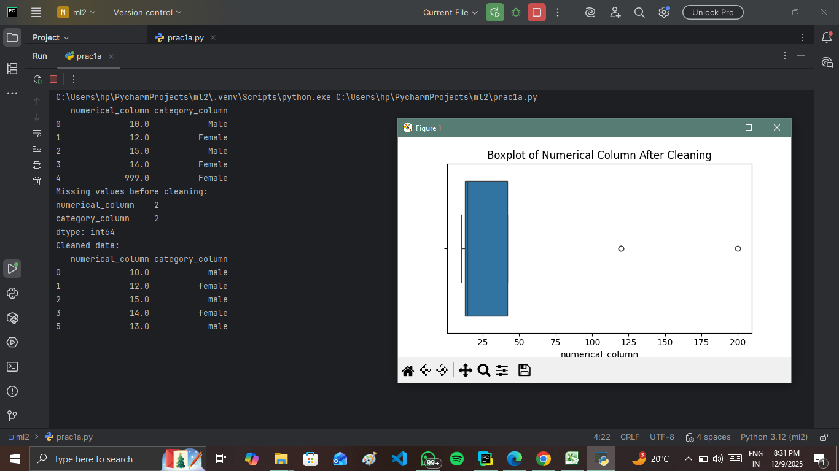

(B). Load a dataset, calculate descriptive summary statistics, create visualizations using different graphs, and identify potential features and target variables
import matplotlib.pyplot as plt
import seaborn as sns
# Load the Iris dataset
df = sns.load_dataset("iris")

# 1. Descriptive Statistics
print(df.describe())

# 2. Univariate Visualizations
# a. Histogram for 'sepal_length'
plt.figure(figsize=(8, 6))
sns.histplot(df['sepal_length'], kde=True, bins=20, color='blue')
plt.title('Distribution of Sepal Length')
plt.xlabel('Sepal Length (cm)')
plt.ylabel('Frequency')
plt.show()

# b. Boxplot for 'petal_length'
plt.figure(figsize=(8, 6))
sns.boxplot(x=df['petal_length'], color='green')
plt.title('Boxplot of Petal Length')
plt.xlabel('Petal Length (cm)')
plt.show()

# c. Density plot for 'sepal_width'
plt.figure(figsize=(8, 6))
sns.kdeplot(df['sepal_width'], shade=True, color='red')
plt.title('Density Plot of Sepal Width')
plt.xlabel('Sepal Width (cm)')
plt.ylabel('Density')
plt.show()

# 3. Bivariate Visualizations
# a. Scatter plot for Sepal Length vs Sepal Width
plt.figure(figsize=(8, 6))

sns.scatterplot(x='sepal_length', y='sepal_width', data=df, hue='species')
plt.title('Sepal Length vs Sepal Width')
plt.xlabel('Sepal Length (cm)')
plt.ylabel('Sepal Width (cm)')
plt.show()
# b. Pairplot of all numerical variables
sns.pairplot(df, hue='species')
plt.show()
# c. Correlation Heatmap
corr_matrix = df.corr()
plt.figure(figsize=(8, 6))
sns.heatmap(corr_matrix, annot=True, cmap='coolwarm', fmt='.2f', linewidths=0.5)
plt.title('Correlation Heatmap of Numerical Features')
plt.show()

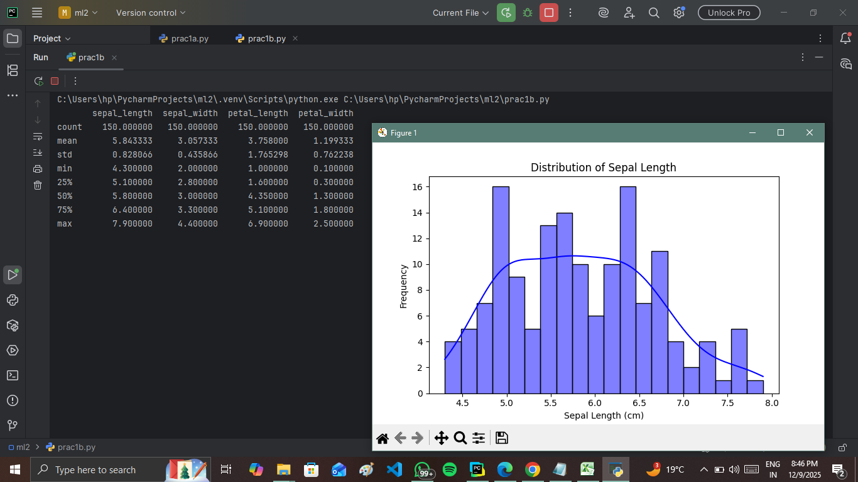
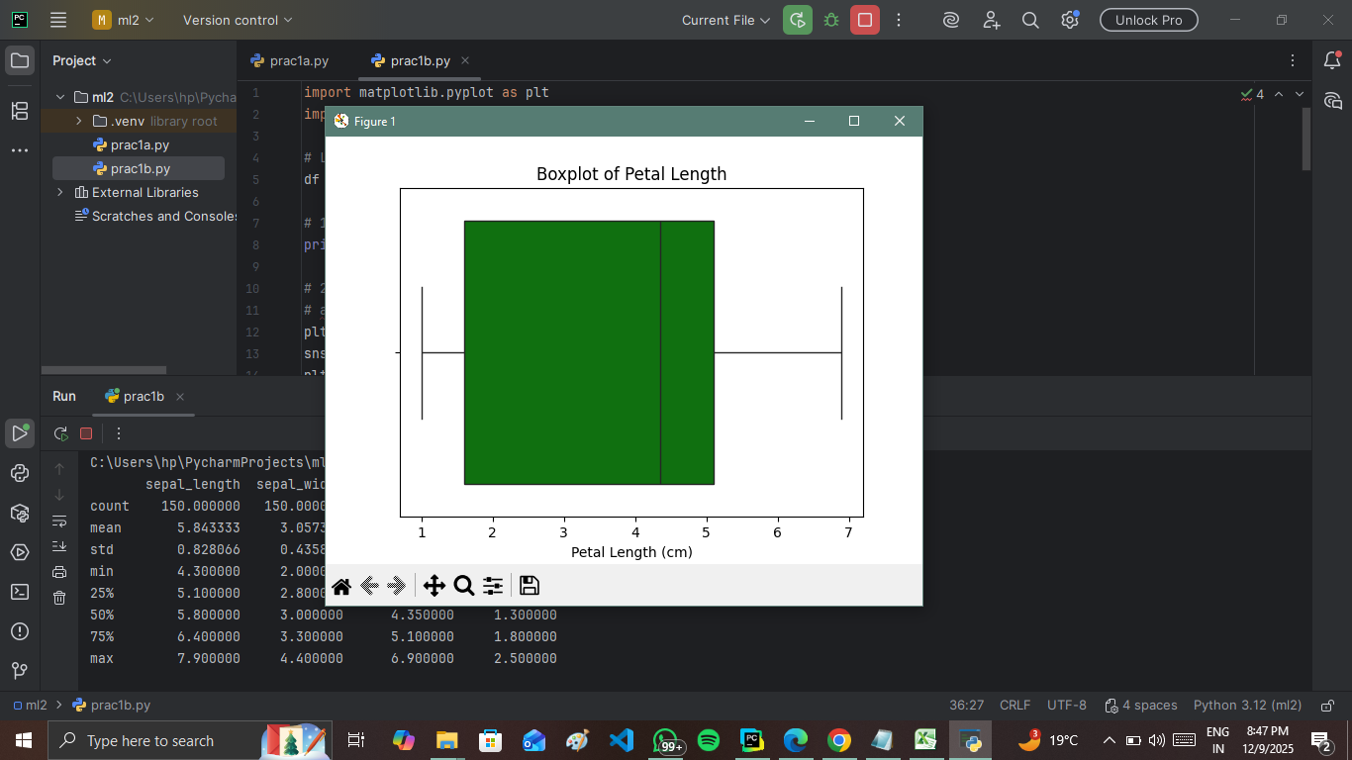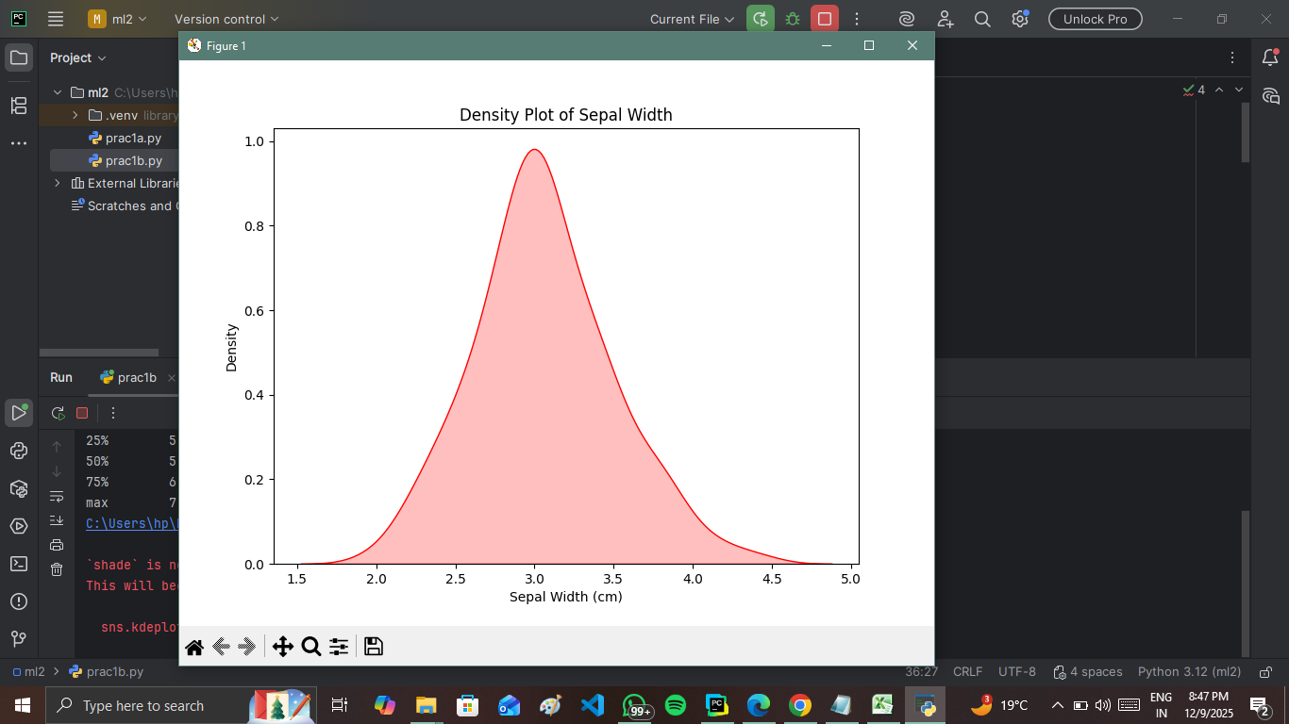

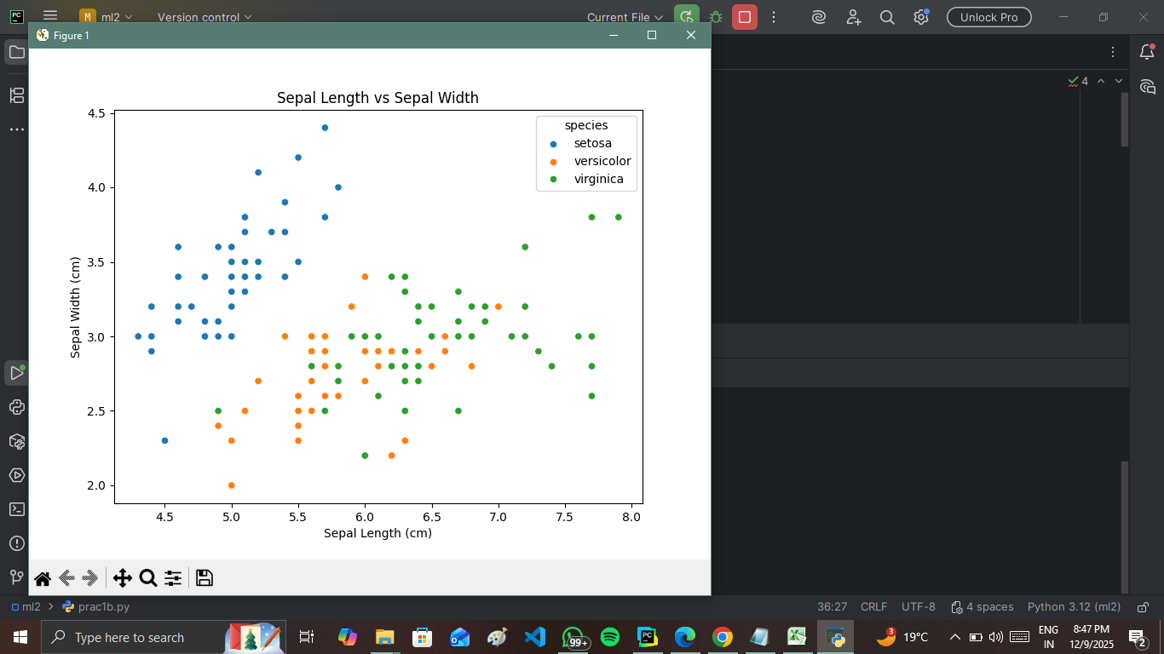
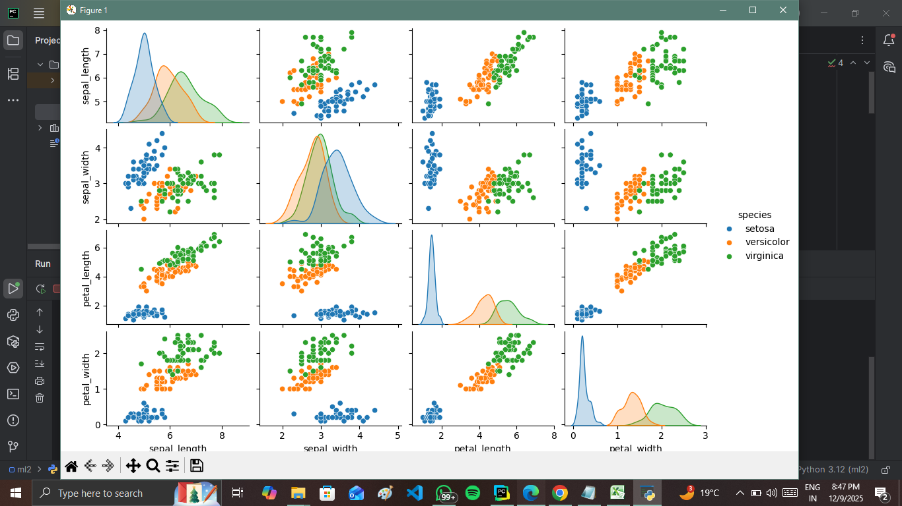

(C). Create or Explore datasets to use all pre-processing routines like label encoding, scaling, and binarization.
import pandas as pd
import numpy as np
from sklearn.preprocessing import LabelEncoder, StandardScaler, MinMaxScaler, Binarizer

# Step 2: Create a synthetic dataset
data = {
"Numerical_Column": [10, 20, 30, 40, 50],
"Categorical_Column": ["Low", "Medium", "High", "Medium", "Low"],
"Binary_Column": [1, 0, 1, 0, 1]
}

# Convert to a DataFrame
df = pd.DataFrame(data)

# Step 3: Handle missing values (if any)
# Here we simulate missing values and fill them
df.loc[1, "Numerical_Column"] = np.nan
df["Numerical_Column"] = df["Numerical_Column"].fillna(df["Numerical_Column"].mean())

# Step 4: Apply Label Encoding to the categorical column
label_encoder = LabelEncoder()
df["Categorical_Column_Encoded"] = label_encoder.fit_transform(df["Categorical_Column"])

# Step 5: Scale numerical columns
scaler = StandardScaler()
df["Numerical_Scaled"] = scaler.fit_transform(df[["Numerical_Column"]])

# Min-Max Scaling for comparison
min_max_scaler = MinMaxScaler()
df["Numerical_MinMax_Scaled"] = min_max_scaler.fit_transform(df[["Numerical_Column"]])

# Step 6: Apply Binarization to numerical columns
binarizer = Binarizer(threshold=25)
df["Numerical_Binarized"] = binarizer.fit_transform(df[["Numerical_Column"]])

# Print the resulting DataFrame
print(df)

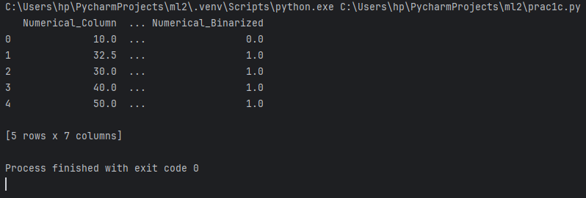

Practical No. 2

Testing Hypothesis

(A). Implement and demonstrate the FIND-S algorithm for finding the most specific hypothesis based on a given set of training data samples. Read the training data from a. CSV file and generate the final specific hypothesis. (Create your dataset)

import pandas as pd
# Step 1: Create a simple dataset and save it to a CSV file
data = {
"Sky": ["Sunny", "Sunny", "Rainy", "Sunny", "Sunny"],
"AirTemp": ["Warm", "Warm", "Cold", "Warm", "Warm"],
"Humidity": ["Normal", "High", "High", "High", "Normal"],
"Wind": ["Strong", "Strong", "Strong", "Strong", "Strong"],
"Water": ["Warm", "Warm", "Warm", "Cool", "Warm"],
"Forecast": ["Same", "Same", "Change", "Same", "Same"],
"EnjoySport": ["Yes", "Yes", "No", "Yes", "Yes"]
}
# Save dataset to CSV for demonstration purposes
df = pd.DataFrame(data)
df.to_csv("training_data.csv", index=False)
# Step 2: Load the training data from CSV
training_data = pd.read_csv("training_data.csv")
# Step 3: Implement FIND-S algorithm
def find_s_algorithm(data):
# Extract features and target
features = data.iloc[:, :-1].values # All columns except the last
target = data.iloc[:, -1].values # The last column (target)

# Initialize the most specific hypothesis
hypothesis = ["ϕ"] * features.shape[1] # Start with the most specific hypothesis

# Update hypothesis for positive examples
for i, row in enumerate(features):
if target[i] == "Yes": # Consider only positive examples
for j in range(len(hypothesis)):
if hypothesis[j] == "ϕ": # Update if still specific
hypothesis[j] = row[j]
elif hypothesis[j] != row[j]: # Generalize if mismatch
hypothesis[j] = "?"

return hypothesis
# Step 4: Run the FIND-S algorithm
final_hypothesis = find_s_algorithm(training_data)
# Step 5: Display the results
print("Final Specific Hypothesis:", final_hypothesis)

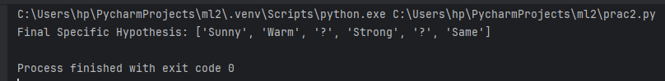

Practical No. 3

Linear Models

(A) Simple Linear Regression Fit a linear regression model on a dataset. Interpret coefficients, make predictions, and evaluate performance using metrics like R-squared and MSE
import pandas as pd
import numpy as np
import matplotlib.pyplot as plt
import seaborn as sns
from sklearn.model_selection import train_test_split
from sklearn.linear_model import LinearRegression
from sklearn.metrics import mean_squared_error, r2_score
from sklearn.datasets import load_diabetes

# Load the diabetes dataset
data = load_diabetes()
# Convert the dataset to a pandas DataFrame
df = pd.DataFrame(data.data, columns=data.feature_names)
df['target'] = data.target
# Show the first few rows of the dataframe
print(df.head())
# Split the data into features (X) and target (y)
X = df.drop('target', axis=1)
y = df['target']
# Split the dataset into training and testing sets
X_train, X_test, y_train, y_test = train_test_split(X, y, test_size=0.2, random_state=42)
# Create a linear regression model
model = LinearRegression()
# Train the model
model.fit(X_train, y_train)
# Make predictions
y_pred = model.predict(X_test)
# Calculate the mean squared error and R2 score
mse = mean_squared_error(y_test, y_pred)
r2 = r2_score(y_test, y_pred)
print(f"Mean Squared Error: {mse}")
print(f"R2 Score: {r2}")
# Visualize the predicted vs. actual values
plt.figure(figsize=(8, 6))
plt.scatter(y_test, y_pred)
plt.plot([min(y_test), max(y_test)], [min(y_test), max(y_test)], color='red', linestyle='--')
plt.xlabel("Actual")
plt.ylabel("Predicted")
plt.title("Actual vs Predicted Values")
plt.show()
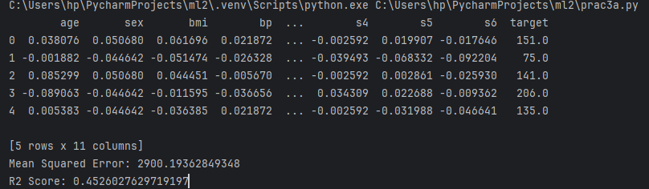
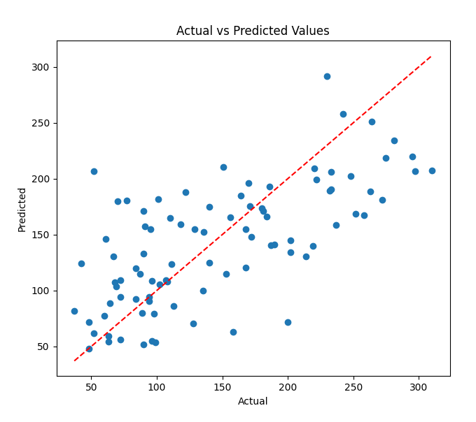

(B). Multiple Linear Regression Extend linear regression to multiple features. Handle feature selection and potential multicollinearity.
# Import necessary libraries
import pandas as pd
import numpy as np
import matplotlib.pyplot as plt
import seaborn as sns
from sklearn.model_selection import train_test_split
from sklearn.linear_model import LinearRegression, Lasso
from sklearn.preprocessing import StandardScaler
from sklearn.metrics import mean_squared_error, r2_score
from statsmodels.stats.outliers_influence import variance_inflation_factor
from statsmodels.tools.tools import add_constant
from sklearn.datasets import load_diabetes

# Load the Diabetes dataset
diabetes = load_diabetes()

# Convert it into a pandas DataFrame
df = pd.DataFrame(diabetes.data, columns=diabetes.feature_names)

# Add the target variable (diabetes progression) to the dataframe
df['PROGRESSION'] = diabetes.target
# Display the first few rows of the dataset
print("Dataset Overview:")
print(df.head(), "\n")

# Check for multicollinearity using the correlation matrix
corr_matrix = df.corr()
plt.figure(figsize=(10, 8))
sns.heatmap(corr_matrix, annot=True, cmap='coolwarm', fmt=".2f", linewidths=0.5)
plt.title("Correlation Matrix")
plt.show()

# Check Variance Inflation Factor (VIF) to detect multicollinearity
X = df.drop(columns=['PROGRESSION'])
X_with_const = add_constant(X) # Add constant to the features
vif_data = pd.DataFrame()
vif_data["Feature"] = X_with_const.columns
vif_data["VIF"] = [variance_inflation_factor(X_with_const.values, i) for i in
range(X_with_const.shape[1])]

print("\nVariance Inflation Factor (VIF):")
print(vif_data, "\n")

# Remove features with high VIF (>10), or use Lasso Regression to handle feature selection
X_selected = X.drop(columns=['s5', 's4']) # Drop highly correlated features, based on VIF analysis

# Split the dataset into features (X) and target (y)
X = X_selected
y = df['PROGRESSION']

# Standardize the features (important for regularization)
scaler = StandardScaler()
X_scaled = scaler.fit_transform(X)

# Split the data into training and testing sets (80% training, 20% testing)
X_train, X_test, y_train, y_test = train_test_split(X_scaled, y, test_size=0.2, random_state=42)

# Initialize and train the Multiple Linear Regression model
model = LinearRegression()
model.fit(X_train, y_train)

# Get the model's coefficients and intercept
intercept = model.intercept_
coefficients = model.coef_

print(f"\nIntercept: {intercept}")
print(f"Coefficients: {coefficients}\n")
# Make predictions using the test set
y_pred = model.predict(X_test)

# Compare actual vs predicted values
comparison_df = pd.DataFrame({'Actual': y_test, 'Predicted': y_pred})
print("Actual vs Predicted Progression (for the first 5 records):")
print(comparison_df.head(), "\n")

# Calculate R-squared (R²) and Mean Squared Error (MSE)
r2 = r2_score(y_test, y_pred)
mse = mean_squared_error(y_test, y_pred)

print(f"R-squared: {r2}")
print(f"Mean Squared Error (MSE): {mse}\n")

# Visualize the regression line (if it were 2D) or scatter plot of actual vs predicted
plt.figure(figsize=(8, 6))
plt.scatter(y_test, y_pred, color='blue')
plt.plot([y_test.min(), y_test.max()], [y_test.min(), y_test.max()], color='red', linestyle='--')
plt.title('Actual vs Predicted Progression')
plt.xlabel('Actual Progression')
plt.ylabel('Predicted Progression')
plt.show()

# Regularization using Lasso (L1) Regression to perform feature selection
lasso = Lasso(alpha=0.1) # Regularization strength (alpha)
lasso.fit(X_train, y_train)

# Display Lasso coefficients (some of them might be zero, meaning the feature is not important)
lasso_coefficients = lasso.coef_
print(f"Lasso Coefficients: {lasso_coefficients}\n")

# Make predictions using Lasso model
y_pred_lasso = lasso.predict(X_test)

# Calculate R-squared and MSE for Lasso model
r2_lasso = r2_score(y_test, y_pred_lasso)
mse_lasso = mean_squared_error(y_test, y_pred_lasso)

print(f"Lasso R-squared: {r2_lasso}")
print(f"Lasso Mean Squared Error (MSE): {mse_lasso}\n")

# Plot Lasso regression predictions
plt.figure(figsize=(8, 6))
plt.scatter(y_test, y_pred_lasso, color='green')
plt.plot([y_test.min(), y_test.max()], [y_test.min(), y_test.max()], color='red', linestyle='--')
plt.title('Actual vs Predicted Progression (Lasso Regression)')
plt.xlabel('Actual Progression')
plt.ylabel('Predicted Progression (Lasso)')
plt.show()

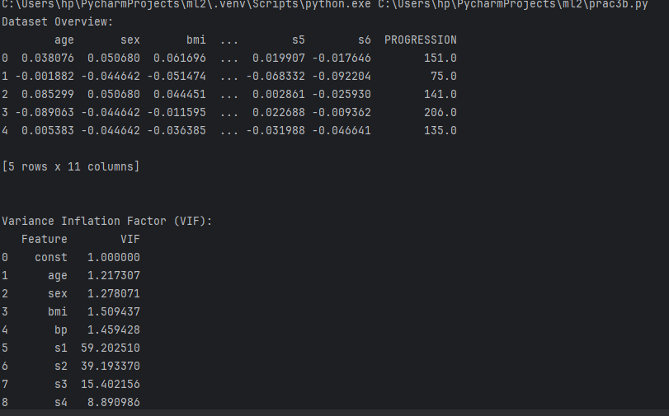
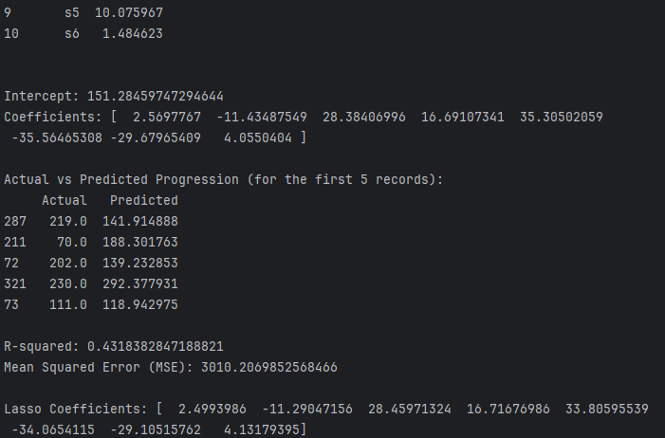
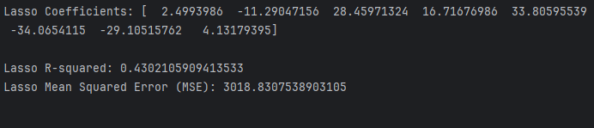

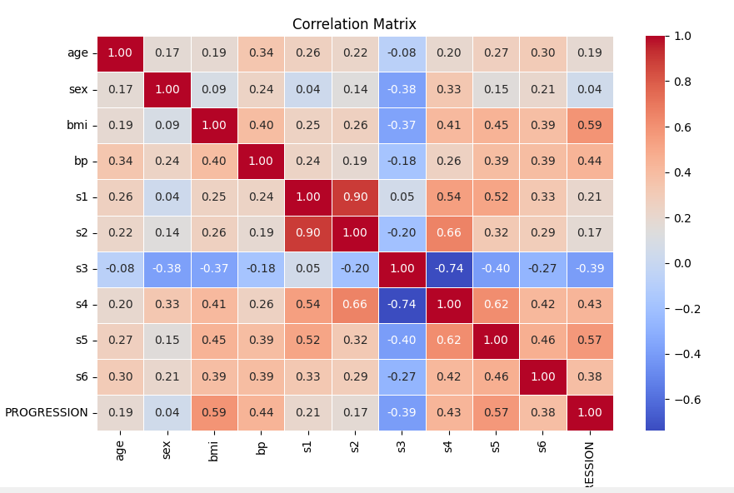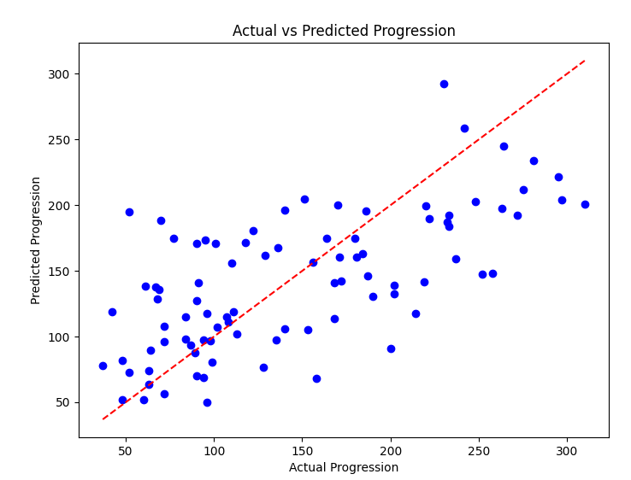
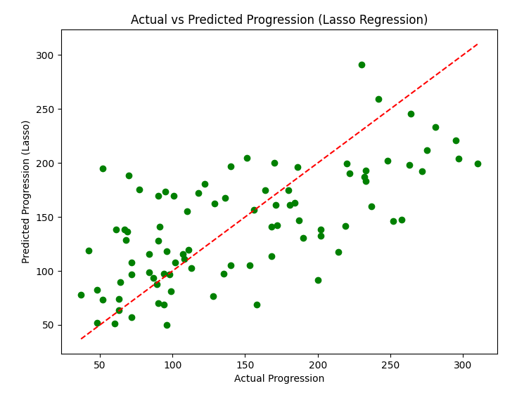
(C) . Regularized Linear Models (Ridge, Lasso, Elastic Net) Implement regression variants like LASSO and Ridge on any generated dataset.
import numpy as np
import matplotlib.pyplot as plt
from sklearn.datasets import make_regression
from sklearn.model_selection import train_test_split
from sklearn.linear_model import Ridge, Lasso, ElasticNet
from sklearn.metrics import mean_squared_error, r2_score

# Step 1: Generate a synthetic dataset
X, y = make_regression(n_samples=100, n_features=10, noise=0.1, random_state=42)

# Split the dataset into training and testing sets
X_train, X_test, y_train, y_test = train_test_split(X, y, test_size=0.2, random_state=42)

# Step 2: Apply Ridge, Lasso, and ElasticNet regression models
ridge = Ridge(alpha=1.0)
lasso = Lasso(alpha=0.1)
elastic_net = ElasticNet(alpha=0.1, l1_ratio=0.5) # l1_ratio = 0.5 is a good start for mixing L1 and L2

# Train the models
ridge.fit(X_train, y_train)
lasso.fit(X_train, y_train)
elastic_net.fit(X_train, y_train)
# Step 3: Predictions
y_pred_ridge = ridge.predict(X_test)
y_pred_lasso = lasso.predict(X_test)
y_pred_elastic_net = elastic_net.predict(X_test)
# Step 4: Evaluate the models using MSE and R² score
mse_ridge = mean_squared_error(y_test, y_pred_ridge)
mse_lasso = mean_squared_error(y_test, y_pred_lasso)
mse_elastic_net = mean_squared_error(y_test, y_pred_elastic_net)
r2_ridge = r2_score(y_test, y_pred_ridge)
r2_lasso = r2_score(y_test, y_pred_lasso)
r2_elastic_net = r2_score(y_test, y_pred_elastic_net)

# Print the results
print(f"Ridge Regression MSE: {mse_ridge:.4f}, R²: {r2_ridge:.4f}")
print(f"Lasso Regression MSE: {mse_lasso:.4f}, R²: {r2_lasso:.4f}")
print(f"ElasticNet Regression MSE: {mse_elastic_net:.4f}, R²: {r2_elastic_net:.4f}")

# Step 5: Plot the results (optional, just for visualization)
plt.figure(figsize=(10, 6))
plt.plot(y_test, label='True values', linestyle='-', marker='o', markersize=5)
plt.plot(y_pred_ridge, label='Ridge predictions', linestyle='-', marker='x', markersize=5)
plt.plot(y_pred_lasso, label='Lasso predictions', linestyle='-', marker='x', markersize=5)
plt.plot(y_pred_elastic_net, label='ElasticNet predictions', linestyle='-', marker='x', markersize=5)
plt.legend()
plt.title('Regression Model Predictions vs True Values')
plt.show()

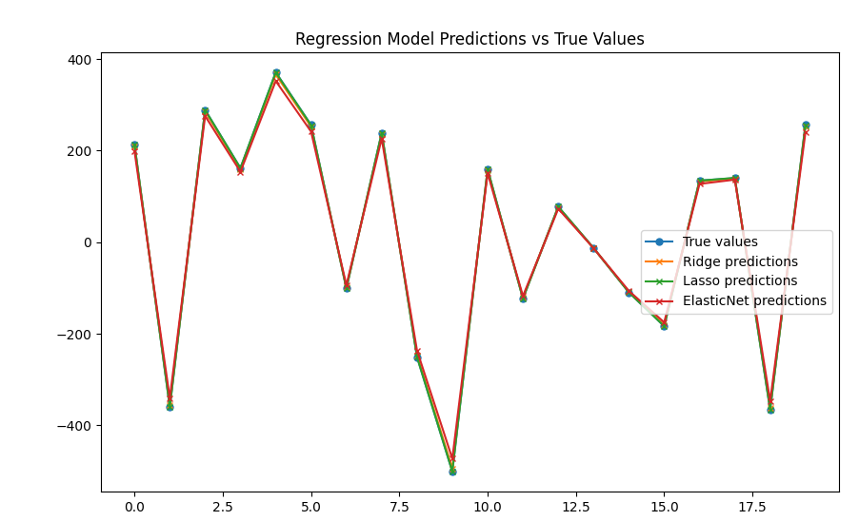

Practical No. 4

Logistic Regression

(A). Perform binary classification using logistic regression. Calculate accuracy, precision, recall, and understand the ROC curve.

import numpy as np
import pandas as pd
from sklearn.model_selection import train_test_split
from sklearn.linear_model import LogisticRegression
from sklearn.metrics import accuracy_score, precision_score, recall_score, roc_curve, auc
import matplotlib.pyplot as plt
import seaborn as sns
# Sample dataset: load it using scikit-learn
from sklearn.datasets import load_iris

iris = load_iris()

# We will use only two classes (binary classification) from the Iris dataset
X = iris.data[iris.target != 2] # Features
y = iris.target[iris.target != 2] # Target variable
# Split the data into training and testing sets (80% train, 20% test)
X_train, X_test, y_train, y_test = train_test_split(X, y, test_size=0.2, random_state=42)
# Initialize the Logistic Regression model
model = LogisticRegression()
# Train the model
model.fit(X_train, y_train)
# Make predictions on the test set
y_pred = model.predict(X_test)

# Predict probabilities for ROC curve (output probabilities for class 1)
y_prob = model.predict_proba(X_test)[:, 1]
accuracy = accuracy_score(y_test, y_pred)
print(f'Accuracy: {accuracy:.4f}')
precision = precision_score(y_test, y_pred)
print(f'Precision: {precision:.4f}')
recall = recall_score(y_test, y_pred)
print(f'Recall: {recall:.4f}')
# Compute ROC curve
fpr, tpr, thresholds = roc_curve(y_test, y_prob)

# Compute the Area Under the Curve (AUC)
roc_auc = auc(fpr, tpr)
# Plot ROC curve
plt.figure(figsize=(8, 6))
plt.plot(fpr, tpr, color='blue', lw=2, label=f'ROC curve (area = {roc_auc:.2f})')
plt.plot([0, 1], [0, 1], color='gray', lw=2, linestyle='--') # Diagonal line (no skill)
plt.xlabel('False Positive Rate')
plt.ylabel('True Positive Rate')
plt.title('Receiver Operating Characteristic (ROC) Curve')
plt.legend(loc='lower right')
plt.show()
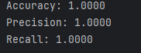
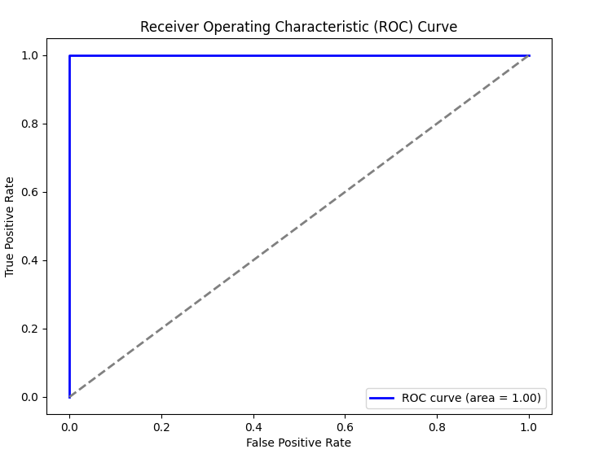

(B). Implement and demonstrate k-nearest Neighbor algorithm. Read the training data from a .CSV file and build the model to classify a test sample. Print both correct and wrong predictions.
import pandas as pd
from sklearn.model_selection import train_test_split
from sklearn.neighbors import KNeighborsClassifier
from sklearn.metrics import accuracy_score

# Step 1: Read training data from a CSV file
# Let's assume the CSV file has feature columns and the target column is named 'class'.
data = pd.read_csv('data1.csv') # Update with your actual file path

# Split the data into features (X) and target labels (y)
X = data.drop(columns=['class']) # All columns except 'class'
y = data['class'] # The target column

# Step 2: Split the data into training and testing sets
X_train, X_test, y_train, y_test = train_test_split(X, y, test_size=0.2, random_state=42)

# Step 3: Initialize the k-NN classifier and train the model
k = 3 # You can change k to any number for the number of neighbors
knn = KNeighborsClassifier(n_neighbors=k)
knn.fit(X_train, y_train)

# Step 4: Predict the labels for the test set
y_pred = knn.predict(X_test)

# Step 5: Print correct and wrong predictions with sample data
for i in range(len(X_test)):
sample = X_test.iloc[i]
true_label = y_test.iloc[i]
predicted_label = y_pred[i]

if true_label == predicted_label:
print(f"Correct: Sample {i + 1} -> Features: {sample.values} | True label: {true_label} | Predicted: {predicted_label} ")
else:
print(f"Wrong: Sample {i + 1} -> Features: {sample.values} | True label: {true_label} | Predicted: {predicted_label} ")

# Step 6: Evaluate the accuracy
accuracy = accuracy_score(y_test, y_pred)
print(f"\nModel Accuracy: {accuracy * 100:.2f}%")
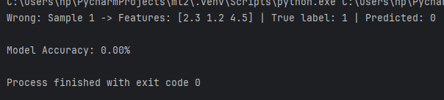

(C). Build a decision tree classifier or regressor. Control hyperparameters like tree depth to avoid overfitting. Visualize the tree.

import pandas as pd
import numpy as np
from sklearn.model_selection import train_test_split
from sklearn.tree import DecisionTreeClassifier, DecisionTreeRegressor, plot_tree
from sklearn.datasets import load_iris
import matplotlib.pyplot as plt

# Step 1: Load a Sample Dataset
# For example, we use the iris dataset available in scikit-learn
iris = load_iris()
X = iris.data
y = iris.target
# Step 2: Split the dataset into training and testing sets
X_train, X_test, y_train, y_test = train_test_split(X, y, test_size=0.2, random_state=42)

# Step 3: Create and Train a Decision Tree Classifier (Control max depth to avoid overfitting)
clf = DecisionTreeClassifier(max_depth=3, random_state=42) # max_depth controls overfitting
clf.fit(X_train, y_train)

# Step 4: Evaluate the Model (Optional)
train_accuracy = clf.score(X_train, y_train)
test_accuracy = clf.score(X_test, y_test)
print(f"Training Accuracy: {train_accuracy}")
print(f"Testing Accuracy: {test_accuracy}")

# Step 5: Visualize the Decision Tree
plt.figure(figsize=(12, 8))
plot_tree(clf, filled=True, feature_names=iris.feature_names, class_names=iris.target_names)
plt.show()
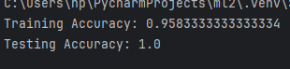
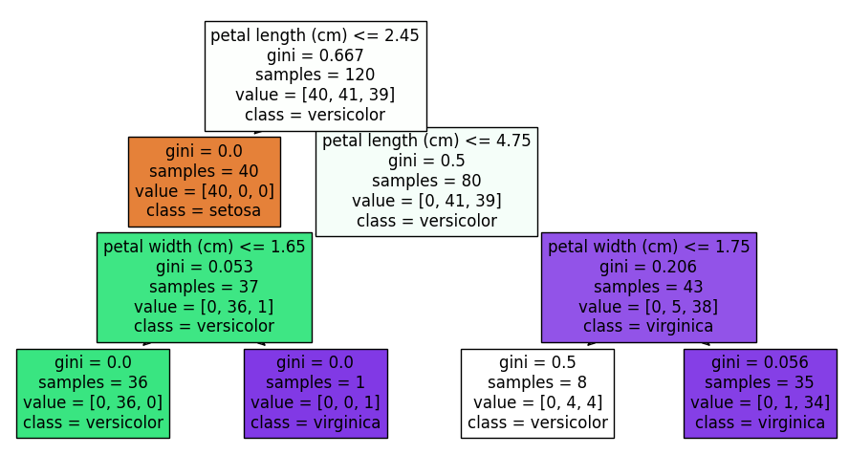

(D). Implement a Support Vector Machine for any relevant dataset.

import numpy as np
import pandas as pd
import matplotlib.pyplot as plt
from sklearn.model_selection import train_test_split
from sklearn.svm import SVC
from sklearn.metrics import accuracy_score, precision_score, recall_score, confusion_matrix
from sklearn.datasets import load_iris

# Load the dataset (Iris dataset)
iris = load_iris()
X = iris.data
y = iris.target

# Binarize the target labels for binary classification
# Here we will focus on 'setosa' (class 0) vs. 'non-setosa' (classes 1 and 2)
y_binary = (y == 0).astype(int) # '1' for Setosa, '0' for non-Setosa

# Split the data into training and testing sets (80% training, 20% testing)
X_train, X_test, y_train, y_test = train_test_split(X, y_binary, test_size=0.2, random_state=42)

# Initialize Support Vector Machine model with a linear kernel
svm_model = SVC(kernel='linear') # You can change kernel to 'rbf' for non-linear

# Train the model on the training set
svm_model.fit(X_train, y_train)
# Make predictions on the test set
y_pred = svm_model.predict(X_test)

# Calculate accuracy, precision, and recall
accuracy = accuracy_score(y_test, y_pred)
precision = precision_score(y_test, y_pred)
recall = recall_score(y_test, y_pred)

print(f"Accuracy: {accuracy:.4f}")
print(f"Precision: {precision:.4f}")
print(f"Recall: {recall:.4f}")

# Confusion Matrix
cm = confusion_matrix(y_test, y_pred)
print("\nConfusion Matrix:")
print(cm)

# Plot the decision boundary (only for 2D features)
# To simplify, we select two features: 'sepal length' and 'sepal width' for visualization
X_train_2d = X_train[:, :2] # First two features (sepal length and sepal width)
X_test_2d = X_test[:, :2]

# Train the model again on the 2D data
svm_model.fit(X_train_2d, y_train)

# Create a meshgrid for plotting the decision boundary
x_min, x_max = X_train_2d[:, 0].min() - 1, X_train_2d[:, 0].max() + 1
y_min, y_max = X_train_2d[:, 1].min() - 1, X_train_2d[:, 1].max() + 1
xx, yy = np.meshgrid(np.arange(x_min, x_max, 0.1),
np.arange(y_min, y_max, 0.1))

# Predict for each point in the meshgrid
Z = svm_model.predict(np.c_[xx.ravel(), yy.ravel()])
Z = Z.reshape(xx.shape)

# Plot the decision boundary
plt.figure(figsize=(8, 6))
plt.contourf(xx, yy, Z, alpha=0.75, cmap='coolwarm')
plt.scatter(X_train_2d[:, 0], X_train_2d[:, 1], c=y_train, edgecolors='k', marker='o', label='Training data')
plt.scatter(X_test_2d[:, 0], X_test_2d[:, 1], c=y_test, edgecolors='r', marker='x', label='Test data')
plt.title('SVM Decision Boundary (Linear Kernel)')
plt.xlabel('Sepal Length')
plt.ylabel('Sepal Width')
plt.legend()
plt.show()

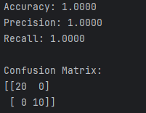
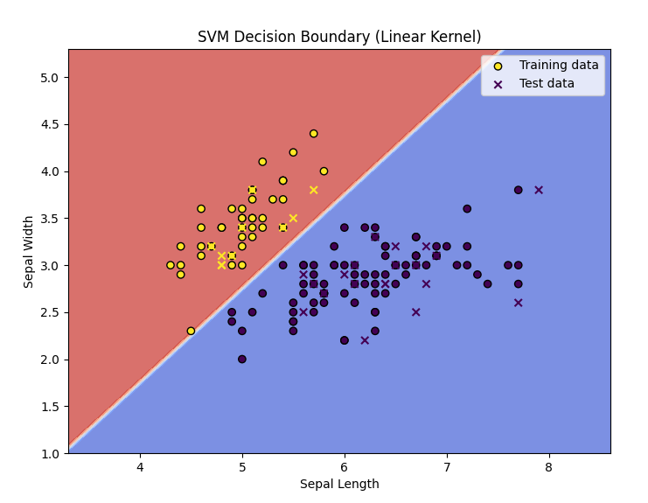

(E)Train a random forest ensemble. Experiment with the number of trees and feature sampling. Compare performance to a single decision tree.

import numpy as np
import pandas as pd
import matplotlib.pyplot as plt
from sklearn.model_selection import train_test_split
from sklearn.tree import DecisionTreeClassifier
from sklearn.ensemble import RandomForestClassifier
from sklearn.metrics import accuracy_score, precision_score, recall_score
from sklearn.datasets import load_iris
# Load the dataset (Iris dataset)
iris = load_iris()
X = iris.data
y = iris.target
# Split the data into training and testing sets (80% training, 20% testing)
X_train, X_test, y_train, y_test = train_test_split(X, y, test_size=0.2, random_state=42)
# 1. Train a single Decision Tree model
dt_model = DecisionTreeClassifier(random_state=42)
dt_model.fit(X_train, y_train)
# Make predictions with the Decision Tree
y_pred_dt = dt_model.predict(X_test)
# Calculate evaluation metrics for the Decision Tree
accuracy_dt = accuracy_score(y_test, y_pred_dt)
precision_dt = precision_score(y_test, y_pred_dt, average='macro')
recall_dt = recall_score(y_test, y_pred_dt, average='macro')
# Print performance for Decision Tree
print("Decision Tree Performance:")
print(f"Accuracy: {accuracy_dt:.4f}")
print(f"Precision: {precision_dt:.4f}")
print(f"Recall: {recall_dt:.4f}\n")

# 2. Train Random Forest models with different numbers of trees (n_estimators) and feature sampling
n_estimators_list = [10, 50, 100, 200]
max_features_list = ['sqrt', 'log2', None] # Corrected feature sampling strategies
results = []

for n_estimators in n_estimators_list:
for max_features in max_features_list:
rf_model = RandomForestClassifier(n_estimators=n_estimators, max_features=max_features,
random_state=42)
rf_model.fit(X_train, y_train)

# Make predictions with the Random Forest
y_pred_rf = rf_model.predict(X_test)

# Calculate evaluation metrics for Random Forest
accuracy_rf = accuracy_score(y_test, y_pred_rf)
precision_rf = precision_score(y_test, y_pred_rf, average='macro')
recall_rf = recall_score(y_test, y_pred_rf, average='macro')

# Save the results
results.append({
'n_estimators': n_estimators,
'max_features': max_features,
'accuracy': accuracy_rf,
'precision': precision_rf,
'recall': recall_rf
})

# Convert the results to a DataFrame for easier comparison
results_df = pd.DataFrame(results)

# Print Random Forest results for comparison
print("\nRandom Forest Performance with different hyperparameters:")
print(results_df)

# 3. Compare the performance of Decision Tree and Random Forest models
# We will plot the accuracy scores for both models to visualize the performance
plt.figure(figsize=(10, 6))
plt.plot(results_df['n_estimators'], results_df['accuracy'], label="Random Forest Accuracy",
marker='o')
plt.axhline(y=accuracy_dt, color='r', linestyle='--', label="Decision Tree Accuracy")
plt.title('Random Forest vs Decision Tree Accuracy')
plt.xlabel('Number of Trees in Random Forest')
plt.ylabel('Accuracy')
plt.legend()
plt.grid(True)
plt.show()

# 4. Plot Precision vs Recall for Random Forest models
plt.figure(figsize=(10, 6))
plt.plot(results_df['n_estimators'], results_df['precision'], label="Random Forest Precision",
marker='o', color='b')

plt.plot(results_df['n_estimators'], results_df['recall'], label="Random Forest Recall", marker='s',
color='g')
plt.axhline(y=precision_dt, color='r', linestyle='--', label="Decision Tree Precision")
plt.axhline(y=recall_dt, color='orange', linestyle='--', label="Decision Tree Recall")
plt.title('Random Forest Precision and Recall vs Decision Tree')
plt.xlabel('Number of Trees in Random Forest')
plt.ylabel('Score')
plt.legend()
plt.grid(True)
plt.show()

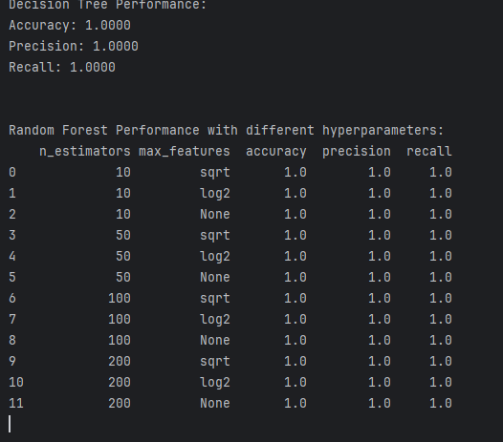
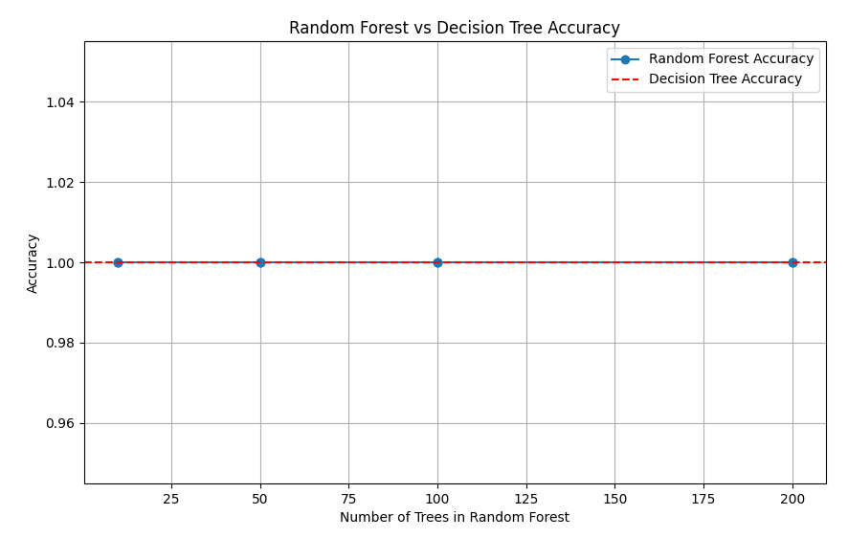

Practical No. 5

Generative Models

(A) Implement and demonstrate the working of a Naive Bayesian classifier using a sample data set build the model to classify a test sample Give the practical for this.

import pandas as pd
import numpy as np
# Step 1: Prepare the data
data = {
'Age': ['<=30', '<=30', '31-40', '31-40', '>40', '>40', '<=30', '>40', '31-40', '<=30'],
'Income': ['High', 'Low', 'High', 'Low', 'High', 'Low', 'High', 'Low', 'High', 'Low'],
'Buys Product': ['No', 'Yes', 'Yes', 'No', 'Yes', 'Yes', 'Yes', 'No', 'No', 'Yes']
}
df = pd.DataFrame(data)

# Step 2: Convert categorical data into numeric values
df['Age'] = df['Age'].map({'<=30': 0, '31-40': 1, '>40': 2})
df['Income'] = df['Income'].map({'Low': 0, 'High': 1})
df['Buys Product'] = df['Buys Product'].map({'No': 0, 'Yes': 1})
# Display the dataset
print("Dataset:")
print(df)

# Step 3: Calculate the prior probabilities (P(Buys Product = Yes) and P(Buys Product = No))
prior_yes = df['Buys Product'].sum() / len(df)
prior_no = 1 - prior_yes

# Step 4: Calculate the conditional probabilities (P(Feature|Class))
# For 'Age' and 'Income', we will calculate conditional probabilities for both classes
# For Age given Buys Product = Yes
prob_age_given_yes = df[df['Buys Product'] == 1]['Age'].value_counts(normalize=True).to_dict()
# For Age given Buys Product = No
prob_age_given_no = df[df['Buys Product'] == 0]['Age'].value_counts(normalize=True).to_dict()
# For Income given Buys Product = Yes
prob_income_given_yes = df[df['Buys Product'] ==
1]['Income'].value_counts(normalize=True).to_dict()
# For Income given Buys Product = No
prob_income_given_no = df[df['Buys Product'] ==
0]['Income'].value_counts(normalize=True).to_dict()

# Step 5: Define the Naive Bayes Classifier function
def naive_bayes_predict(age, income):
# P(Buys Product = Yes)
prob_yes_given_features = prior_yes
if age in prob_age_given_yes:
prob_yes_given_features *= prob_age_given_yes[age]
if income in prob_income_given_yes:
prob_yes_given_features *= prob_income_given_yes[income]
# P(Buys Product = No)
prob_no_given_features = prior_no
if age in prob_age_given_no:
prob_no_given_features *= prob_age_given_no[age]
if income in prob_income_given_no:
prob_no_given_features *= prob_income_given_no[income]
# Normalize and compare
total_prob = prob_yes_given_features + prob_no_given_features
prob_yes_given_features /= total_prob
prob_no_given_features /= total_prob
return "Yes" if prob_yes_given_features > prob_no_given_features else "No"

# Step 6: Test the model with a new sample
test_sample = {'Age': 1, 'Income': 1} # Age = 31-40, Income = High
prediction = naive_bayes_predict(test_sample['Age'], test_sample['Income'])
print("\nPredicted class for the test sample (Age = 31-40, Income = High):", prediction)

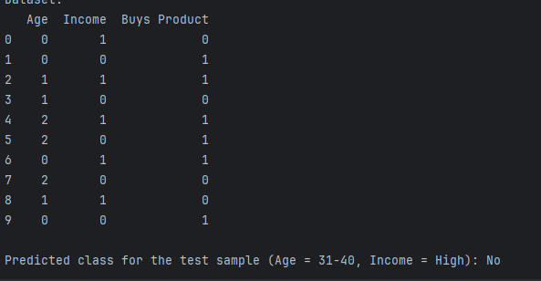

(B)Implement Hidden Markov Models using hmmlearn

import numpy as np
from hmmlearn import hmm
# Step 1: Prepare the data
# Observations: 0 = No Umbrella, 1 = Umbrella
observations = np.array([[0], [0], [1], [1], [0], [1], [0], [1]])
# States: 0 = Sunny, 1 = Rainy
# The hidden state sequence is not provided, we will train the HMM model to predict it
# We will only use the observation sequence for training.
# Step 2: Define and Train the HMM Model
# Define the HMM: 2 hidden states (Sunny, Rainy), 2 possible observations (No Umbrella, Umbrella)
model = hmm.MultinomialHMM(n_components=2, n_iter=1000)
# Train the model on the observations (without the hidden state labels)
model.fit(observations)
# Step 3: Predict the hidden states (weather) given the observations
predicted_states = model.predict(observations)
# Step 4: Output results
print("Predicted Hidden States (Weather):")
print(predicted_states)
# Step 5: Output the model's parameters (transition matrix, emission matrix)
print("\nTransition Matrix (State to State):")
print(model.transmat_)
print("\nEmission Matrix (Observation | State):")
print(model.emissionprob_)
# Step 6: Making predictions for new observations (example)
# Let's predict the weather based on a new sequence of umbrella usage
new_observations = np.array([[0], [1], [1]]) # No Umbrella, Umbrella, Umbrella
predicted_new_states = model.predict(new_observations)
print("\nPredicted Hidden States for New Observations (No Umbrella, Umbrella, Umbrella):")
print(predicted_new_states)

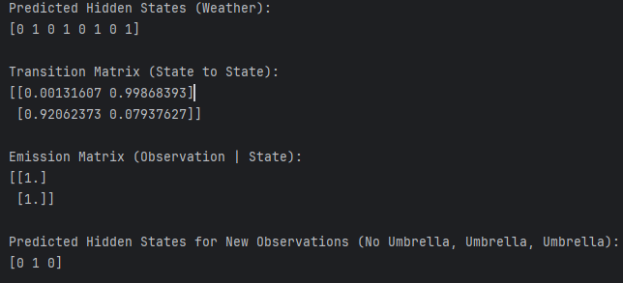

Practical No. 6

Probabilistic Models

(A). Implement Bayesian linear regression to explore prior and posterior distribution.

Code
import numpy as np
import matplotlib.pyplot as plt
import seaborn as sns
from scipy.stats import multivariate_normal
# Set random seed for reproducibility
np.random.seed(42)

# 1. Generate synthetic data (linear relationship with noise)
n_samples = 50
X = np.linspace(0, 10, n_samples)
y_true = 2 * X + 1 # y = 2x + 1 (true coefficients)
noise = np.random.normal(0, 1, n_samples)
y = y_true + noise # observed data with noise
# Plot the data
plt.figure(figsize=(8, 6))
plt.scatter(X, y, label="Observed data", color='blue')
plt.plot(X, y_true, label="True line", color='red', linewidth=2)
plt.xlabel('X')
plt.ylabel('y')
plt.title('Synthetic Data and True Line')
plt.legend()
plt.show()

# 2. Define prior distributions for the parameters (weights)
# Assuming a Normal prior distribution for the weights (slope and intercept)
# We assume a zero-mean prior with a high variance (uninformative prior)
prior_mean = np.array([0, 0]) # [slope, intercept]
prior_cov = np.array([[10, 0], [0, 10]]) # Uncorrelated, high variance

# 3. Compute the posterior distribution using Bayesian formula
# We use the equation: p(w | X, y) ~ p(y | X, w) * p(w)
# p(y | X, w) is the likelihood: N(y | Xw, sigma^2)
# p(w) is the prior: N(w | prior_mean, prior_cov)
# Design matrix (with a column of ones for the intercept)
X_design = np.vstack([X, np.ones_like(X)]).T
# Likelihood covariance (assuming noise variance is known)
sigma_squared = 1 # Variance of the Gaussian noise
likelihood_cov = sigma_squared * np.identity(n_samples)
# Posterior mean and covariance (using the closed-form solution for Bayesian LR)
X_transpose = X_design.T
posterior_cov = np.linalg.inv(np.linalg.inv(prior_cov) + X_transpose @ np.linalg.inv(likelihood_cov) @ X_design)
posterior_mean = posterior_cov @ (np.linalg.inv(prior_cov) @ prior_mean + X_transpose @ np.linalg.inv(likelihood_cov) @ y)

# 4. Plot the prior and posterior distributions
# We will visualize the prior and posterior distributions of the slope and intercept
sns.set(style="whitegrid")

# Plot prior distribution
plt.figure(figsize=(10, 6))
plt.subplot(1, 2, 1)
slope_range = np.linspace(-5, 5, 100)
intercept_range = np.linspace(-5, 5, 100)
slope_grid, intercept_grid = np.meshgrid(slope_range, intercept_range)
prior_pdf = multivariate_normal.pdf(
np.dstack([slope_grid, intercept_grid]), mean=prior_mean, cov=prior_cov)
plt.contour(slope_grid, intercept_grid, prior_pdf, levels=10, cmap='Blues')
plt.title('Prior Distribution')
plt.xlabel('Slope')
plt.ylabel('Intercept')
# Plot posterior distribution
plt.subplot(1, 2, 2)
posterior_pdf = multivariate_normal.pdf(
np.dstack([slope_grid, intercept_grid]), mean=posterior_mean, cov=posterior_cov)
plt.contour(slope_grid, intercept_grid, posterior_pdf, levels=10, cmap='Reds')
plt.title('Posterior Distribution')
plt.xlabel('Slope')
plt.ylabel('Intercept')
plt.tight_layout()
plt.show()
# 5. Make predictions based on the posterior distribution
# Draw samples from the posterior distribution to make predictions
n_samples_posterior = 500
posterior_samples = np.random.multivariate_normal(posterior_mean, posterior_cov, n_samples_posterior)
# Generate predictions using the posterior samples
predictions = np.array([X_design @ sample for sample in posterior_samples])
# Plot the data and the predictive distribution
plt.figure(figsize=(8, 6))
plt.scatter(X, y, color='blue', label='Observed data')
plt.plot(X, y_true, label='True Line', color='red', linewidth=2)
plt.plot(X, np.mean(predictions, axis=0), label='Posterior mean prediction', color='green', linewidth=2)
# Plot the uncertainty in predictions (shaded area)
std_dev = np.std(predictions, axis=0)
plt.fill_between(X, np.mean(predictions, axis=0) - 1.96 * std_dev, np.mean(predictions, axis=0) + 1.96 * std_dev, color='green', alpha=0.2, label='95% prediction interval')
plt.xlabel('X')
plt.ylabel('y')
plt.title('Posterior Predictions with Uncertainty')
plt.legend()
plt.show()

Output 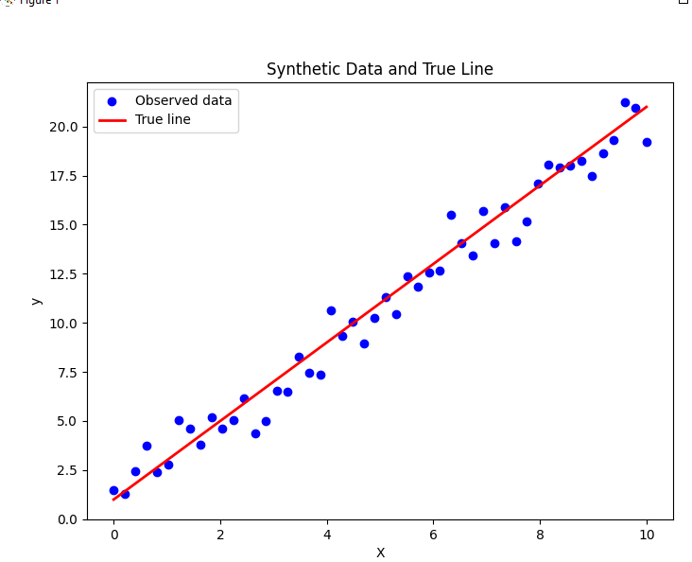

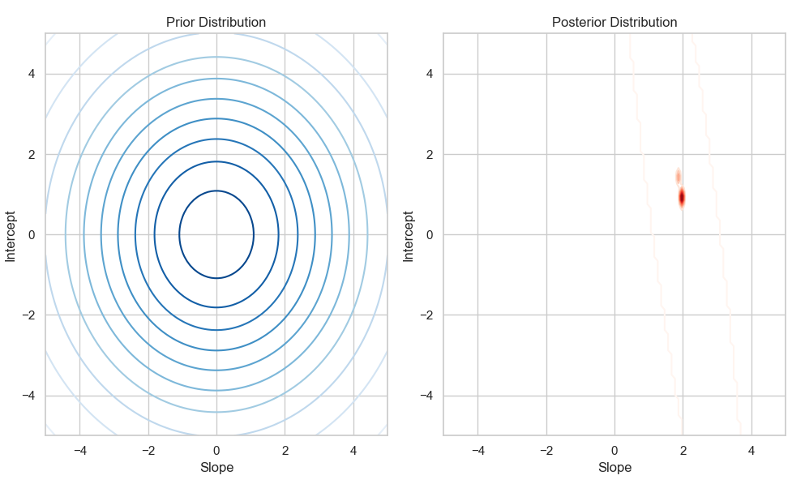
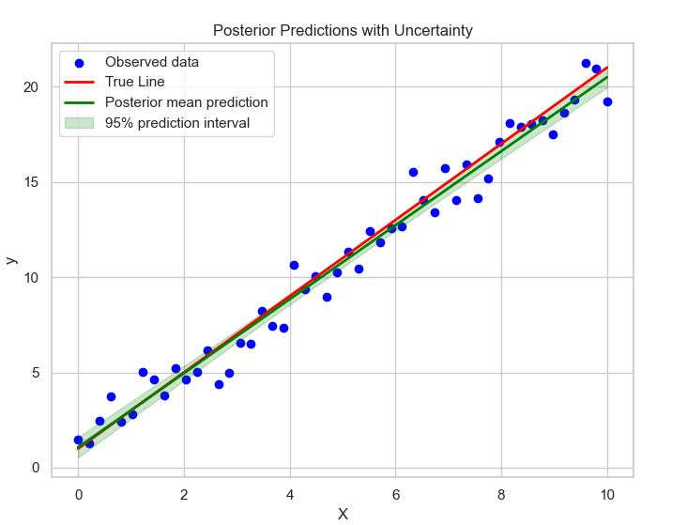

(B). Implement gaussian mixture models for density estimation and unsupervised clustering
Code

import numpy as np
import matplotlib.pyplot as plt
from sklearn.mixture import GaussianMixture
from sklearn.datasets import make_blobs
# Step 1: Generate Synthetic Data (Multiple Gaussian Distributions)
np.random.seed(42)
# Create synthetic data: 3 Gaussian distributions
n_samples = 500
X, _ = make_blobs(n_samples=n_samples, centers=3, cluster_std=0.60, random_state=42)
# Step 2: Fit a Gaussian Mixture Model (GMM) to the data
# Fit a GMM with 3 components (since we know there are 3 clusters)
gmm = GaussianMixture(n_components=3)
gmm.fit(X)
# Step 3: Visualize the data points and the GMM
# Plot the data points
plt.scatter(X[:, 0], X[:, 1], c='black', s=40, label="Data")
# Plot the GMM components (mean of each Gaussian)
means = gmm.means_
covariances = gmm.covariances_
# Plot the ellipses for each Gaussian component (representing the covariance)
for mean, cov in zip(means, covariances):
v, w = np.linalg.eigh(cov)
v = 2.0 * np.sqrt(2.0) * np.sqrt(v)
u = w[0] / np.linalg.norm(w[0])
angle = np.arctan(u[1] / u[0])
angle = 180.0 * angle / np.pi
ell = plt.matplotlib.patches.Ellipse(mean, v[0], v[1], angle=angle, color='red', alpha=0.4)
plt.gca().add_patch(ell)
plt.title('Gaussian Mixture Model Components (Density Estimation)')
plt.xlabel('Feature 1')
plt.ylabel('Feature 2')
plt.show()
# Step 4: Use the GMM for clustering (predict the cluster for each point)
labels = gmm.predict(X)
# Step 5: Visualize the clustering result
plt.scatter(X[:, 0], X[:, 1], c=labels, s=40, cmap='viridis', label="Clustered Data")
plt.title('Clustering Results from GMM')
plt.xlabel('Feature 1')
plt.ylabel('Feature 2')
plt.show()
# Step 6: Density estimation - Plot the GMM's predicted density on a grid
x_min, x_max = X[:, 0].min() - 1, X[:, 0].max() + 1
y_min, y_max = X[:, 1].min() - 1, X[:, 1].max() + 1
xx, yy = np.meshgrid(np.linspace(x_min, x_max, 100), np.linspace(y_min, y_max, 100))
grid_data = np.column_stack([xx.ravel(), yy.ravel()])
# Get the log likelihood (density) of the data points under the GMM
Z = np.exp(gmm.score_samples(grid_data))
Z = Z.reshape(xx.shape)
# Plot the density
plt.contourf(xx, yy, Z, levels=10, cmap='Blues')
plt.scatter(X[:, 0], X[:, 1], c='black', s=40, alpha=0.5, label="Data")
plt.title('Density Estimation with GMM')
plt.xlabel('Feature 1')
plt.ylabel('Feature 2')
plt.show()

output
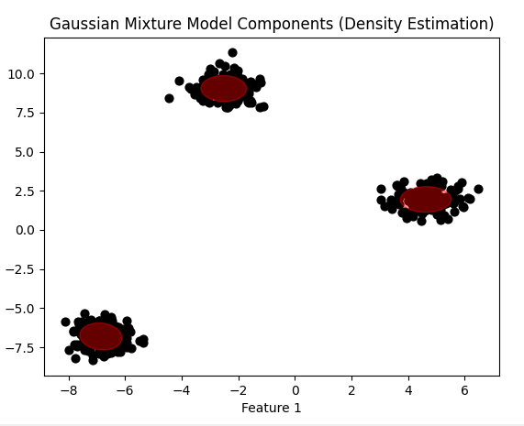
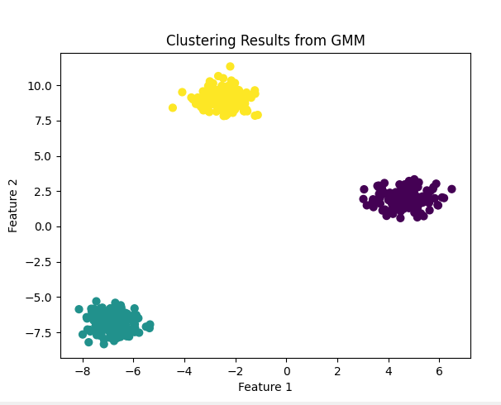

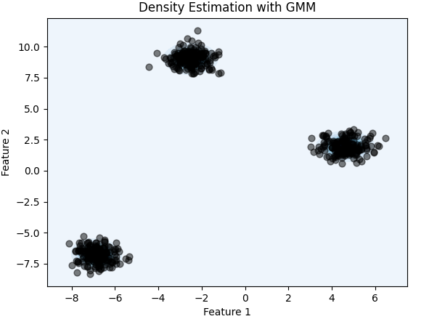

Practical No. 7

Model Evaluation and Hyperparameter Tuning

(A). Implement cross-validation techniques (k-fold, stratified, etc.) for robust model evaluation

Code
from sklearn.datasets import load_iris
from sklearn.model_selection import cross_val_score, KFold, StratifiedKFold
from sklearn.tree import DecisionTreeClassifier
from sklearn.metrics import make_scorer, accuracy_score, f1_score
# Load dataset
data = load_iris()
X, y = data.data, data.target

# Initialize model
model = DecisionTreeClassifier(random_state=42)

# Define k-Fold Cross-Validation
k = 5 # Number of folds
kfold = KFold(n_splits=k, shuffle=True, random_state=42)

# Evaluate with k-Fold CV
kfold_scores = cross_val_score(model, X, y, cv=kfold, scoring='accuracy')
print(f"k-Fold Cross-Validation Accuracy: {kfold_scores}")
print(f"Mean Accuracy (k-Fold): {kfold_scores.mean():.2f}")

# Define Stratified k-Fold Cross-Validation
stratified_kfold = StratifiedKFold(n_splits=k, shuffle=True, random_state=42)

# Evaluate with Stratified k-Fold CV
stratified_scores = cross_val_score(model, X, y, cv=stratified_kfold, scoring='accuracy')
print(f"Stratified k-Fold Cross-Validation Accuracy: {stratified_scores}")
print(f"Mean Accuracy (Stratified k-Fold): {stratified_scores.mean():.2f}")

# Advanced: Custom Scorer with F1-Score
f1_scorer = make_scorer(f1_score, average='weighted')
f1_scores = cross_val_score(model, X, y, cv=stratified_kfold, scoring=f1_scorer)
print(f"Stratified k-Fold Cross-Validation F1-Score: {f1_scores}")
print(f"Mean F1-Score (Stratified k-Fold): {f1_scores.mean():.2f}")

Output
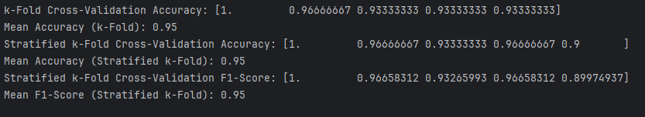

(B). Systematically explore combinations of hyperparameters to optimize model performance. (use grid and randomized search)

Code
import numpy as np
from sklearn.datasets import load_iris
from sklearn.model_selection import train_test_split, GridSearchCV, RandomizedSearchCV
from sklearn.ensemble import RandomForestClassifier
from sklearn.metrics import classification_report
# Load dataset
data = load_iris()
X, y = data.data, data.target
# Split dataset into training and testing sets
X_train, X_test, y_train, y_test = train_test_split(X, y, test_size=0.3, random_state=42)
# Define the model
model = RandomForestClassifier(random_state=42)
# Define the hyperparameter grid for Grid Search
param_grid = {
'n_estimators': [10, 50, 100, 200],
'max_depth': [None, 10, 20, 30],
'min_samples_split': [2, 5, 10],
'min_samples_leaf': [1, 2, 4]
}
# Perform Grid Search
grid_search = GridSearchCV(estimator=model, param_grid=param_grid, cv=5, scoring='accuracy', verbose=1)
grid_search.fit(X_train, y_train)
# Print best parameters and accuracy
print("Best Parameters (Grid Search):", grid_search.best_params_)
print("Best Accuracy (Grid Search):", grid_search.best_score_)
# Define the hyperparameter grid for Randomized Search
param_dist = {
'n_estimators': [int(x) for x in np.linspace(10, 200, num=20)],
'max_depth': [None] + [int(x) for x in np.linspace(10, 30, num=5)],
'min_samples_split': [2, 5, 10],
'min_samples_leaf': [1, 2, 4],
'bootstrap': [True, False]
}
# Perform Randomized Search
random_search = RandomizedSearchCV(estimator=model, param_distributions=param_dist, n_iter=50,
cv=5, scoring='accuracy', random_state=42, verbose=1)
random_search.fit(X_train, y_train)
# Print best parameters and accuracy
print("Best Parameters (Randomized Search):", random_search.best_params_)
print("Best Accuracy (Randomized Search):", random_search.best_score_)
# Evaluate the best model on the test set
best_model = random_search.best_estimator_
y_pred = best_model.predict(X_test)
print("\nClassification Report:\n", classification_report(y_test, y_pred))
output

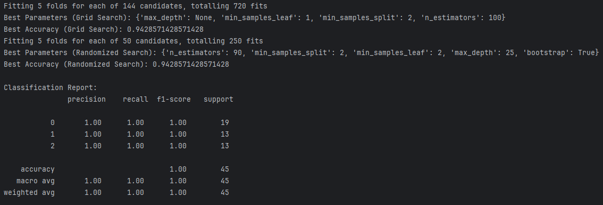

Practical No. 8

Bayesian Learning

(A). Implement Bayesian learning using inferences
Code
import numpy as np
import matplotlib.pyplot as plt
import seaborn as sns
from scipy.stats import multivariate_normal
# Set random seed for reproducibility
np.random.seed(42)
# 1. Generate synthetic data (linear relationship with noise)
n_samples = 50
X = np.linspace(0, 10, n_samples)
y_true = 2 * X + 1 # y = 2x + 1 (true coefficients)
noise = np.random.normal(0, 1, n_samples)
y = y_true + noise # observed data with noise
# Plot the data
plt.figure(figsize=(8, 6))
plt.scatter(X, y, label="Observed data", color='blue')
plt.plot(X, y_true, label="True line", color='red', linewidth=2)
plt.xlabel('X')
plt.ylabel('y')
plt.title('Synthetic Data and True Line')
plt.legend()
plt.show()
# 2. Define prior distributions for the parameters (weights)
# Assuming a Normal prior distribution for the weights (slope and intercept)
# We assume a zero-mean prior with a high variance (uninformative prior)
prior_mean = np.array([0, 0]) # [slope, intercept]
prior_cov = np.array([[10, 0], [0, 10]]) # Uncorrelated, high variance
# 3. Compute the posterior distribution using Bayesian formula
# We use the equation: p(w | X, y) ~ p(y | X, w) * p(w)
# p(y | X, w) is the likelihood: N(y | Xw, sigma^2)
# p(w) is the prior: N(w | prior_mean, prior_cov)
# Design matrix (with a column of ones for the intercept)
X_design = np.vstack([X, np.ones_like(X)]).T
# Likelihood covariance (assuming noise variance is known)
sigma_squared = 1 # Variance of the Gaussian noise
likelihood_cov = sigma_squared * np.identity(n_samples)
# Posterior mean and covariance (using the closed-form solution for Bayesian LR)
X_transpose = X_design.T
posterior_cov = np.linalg.inv(np.linalg.inv(prior_cov) + X_transpose @ np.linalg.inv(likelihood_cov) @ X_design)
posterior_mean = posterior_cov @ (np.linalg.inv(prior_cov) @ prior_mean + X_transpose @ np.linalg.inv(likelihood_cov) @ y)
# 4. Plot the prior and posterior distributions
# We will visualize the prior and posterior distributions of the slope and intercept
sns.set(style="whitegrid")
# Plot prior distribution
plt.figure(figsize=(10, 6))
plt.subplot(1, 2, 1)
slope_range = np.linspace(-5, 5, 100)
intercept_range = np.linspace(-5, 5, 100)
slope_grid, intercept_grid = np.meshgrid(slope_range, intercept_range)
prior_pdf = multivariate_normal.pdf(
np.dstack([slope_grid, intercept_grid]), mean=prior_mean, cov=prior_cov)
plt.contour(slope_grid, intercept_grid, prior_pdf, levels=10, cmap='Blues')
plt.title('Prior Distribution')
plt.xlabel('Slope')
plt.ylabel('Intercept')
# Plot posterior distribution
plt.subplot(1, 2, 2)
posterior_pdf = multivariate_normal.pdf(
np.dstack([slope_grid, intercept_grid]), mean=posterior_mean, cov=posterior_cov)
plt.contour(slope_grid, intercept_grid, posterior_pdf, levels=10, cmap='Reds')
plt.title('Posterior Distribution')
plt.xlabel('Slope')
plt.ylabel('Intercept')
plt.tight_layout()
plt.show()
# 5. Make predictions based on the posterior distribution
# Draw samples from the posterior distribution to make predictions
n_samples_posterior = 500
posterior_samples = np.random.multivariate_normal(posterior_mean, posterior_cov, n_samples_posterior)
# Generate predictions using the posterior samples
predictions = np.array([X_design @ sample for sample in posterior_samples])
# Plot the data and the predictive distribution
plt.figure(figsize=(8, 6))
plt.scatter(X, y, color='blue', label='Observed data')
plt.plot(X, y_true, label='True Line', color='red', linewidth=2)
plt.plot(X, np.mean(predictions, axis=0), label='Posterior mean prediction', color='green', linewidth=2)
# Plot the uncertainty in predictions (shaded area)
std_dev = np.std(predictions, axis=0)
plt.fill_between(X, np.mean(predictions, axis=0) - 1.96 * std_dev, np.mean(predictions, axis=0) + 1.96 * std_dev, color='green', alpha=0.2, label='95% prediction interval')
plt.xlabel('X')
plt.ylabel('y')
plt.title('Posterior Predictions with Uncertainty')
plt.legend()
plt.show()
Output
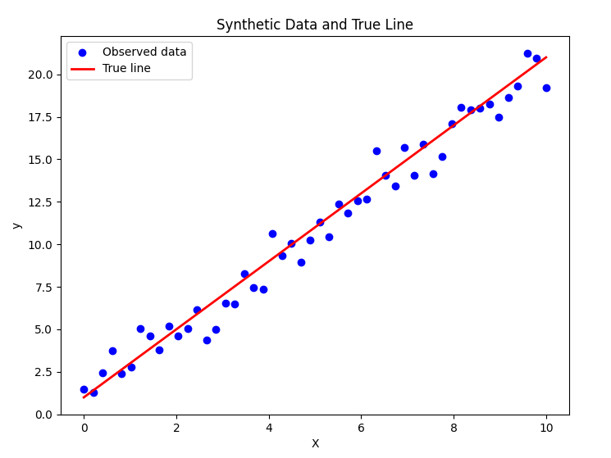

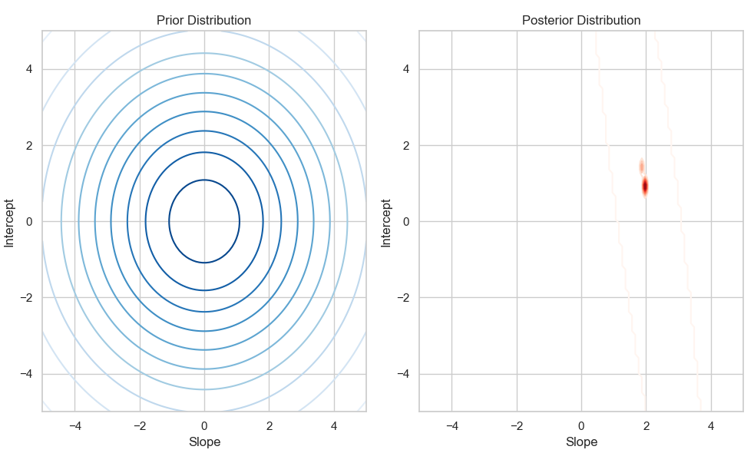
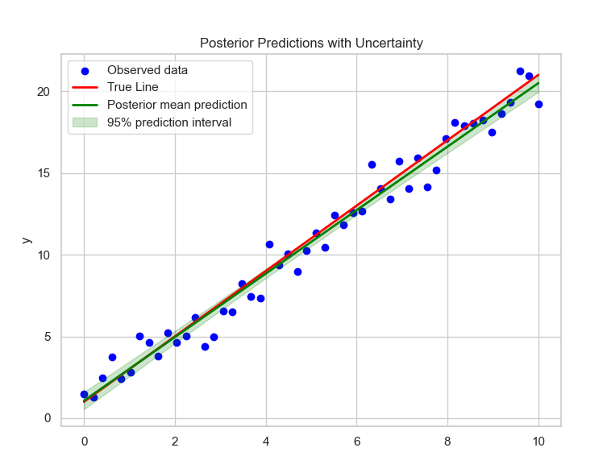

Practical No. 9

Deep Generative Models

(A). Set up a generator network to produce samples and a discriminator network to distinguish between real and generated data. (Use a simple small dataset)

Code
import numpy as np
import tensorflow as tf
from tensorflow.keras import Sequential
from tensorflow.keras.layers import Dense
import matplotlib.pyplot as plt

# Step 1: Create a simple dataset (1D Gaussian distribution)
def generate_real_data(n_samples):
X = np.random.normal(loc=0.0, scale=1.0, size=n_samples) # Mean=0, Stddev=1
y = np.ones((n_samples, 1)) # Labels for real data
return X, y

# Step 2: Define the Generator
def build_generator(latent_dim):
model = Sequential([
Dense(16, activation='relu', input_dim=latent_dim),
Dense(1, activation='linear') # Output is a single number (1D point)
])
return model
# Step 3: Define the Discriminator
def build_discriminator():
model = Sequential([
Dense(16, activation='relu', input_dim=1),
Dense(1, activation='sigmoid') # Output is a probability
])
model.compile(optimizer='adam', loss='binary_crossentropy', metrics=['accuracy'])
return model

# Step 4: Define the GAN
def build_gan(generator, discriminator):
discriminator.trainable = False # Freeze the discriminator during GAN training
model = Sequential([generator, discriminator])
model.compile(optimizer='adam', loss='binary_crossentropy')
return model

# Step 5: Train the GAN
def train_gan(generator, discriminator, gan, latent_dim, n_epochs=10000, n_batch=128, n_eval=1000):
for epoch in range(n_epochs):
# Train the Discriminator
# 1. Real data
X_real, y_real = generate_real_data(n_batch // 2)
d_loss_real = discriminator.train_on_batch(X_real, y_real)

# 2. Fake data
X_fake = generator.predict(np.random.randn(n_batch // 2, latent_dim))
y_fake = np.zeros((n_batch // 2, 1)) # Labels for fake data
d_loss_fake = discriminator.train_on_batch(X_fake, y_fake)

# Train the Generator (via the GAN model)
z_input = np.random.randn(n_batch, latent_dim) # Random noise
y_gan = np.ones((n_batch, 1)) # Labels for GAN training are always 1
g_loss = gan.train_on_batch(z_input, y_gan)

# Evaluate progress
if (epoch + 1) % n_eval == 0:
print(f"Epoch {epoch+1}/{n_epochs}, D Loss Real: {d_loss_real[0]:.3f}, D Loss Fake: {d_loss_fake[0]:.3f}, G Loss: {g_loss:.3f}")
summarize_performance(epoch, generator, latent_dim)

# Step 6: Evaluate and Plot Results
def summarize_performance(epoch, generator, latent_dim, n_samples=100):
X_fake = generator.predict(np.random.randn(n_samples, latent_dim))
plt.hist(X_fake, bins=30, alpha=0.7, label='Generated')
plt.hist(np.random.normal(0.0, 1.0, n_samples), bins=30, alpha=0.7, label='Real')
plt.title(f'Epoch {epoch+1}')
plt.legend()
plt.show()

# Parameters
latent_dim = 5 # Size of random noise vector
n_epochs = 1000
n_batch = 32

# Build and compile models
generator = build_generator(latent_dim)
discriminator = build_discriminator()
gan = build_gan(generator, discriminator)
# Train the GAN
train_gan(generator, discriminator, gan, latent_dim, n_epochs, n_batch, n_eval=1000)

Output
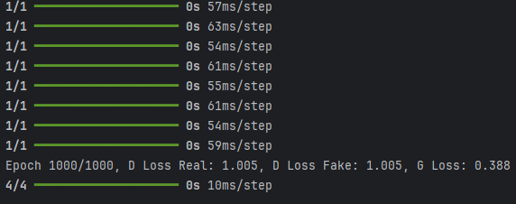

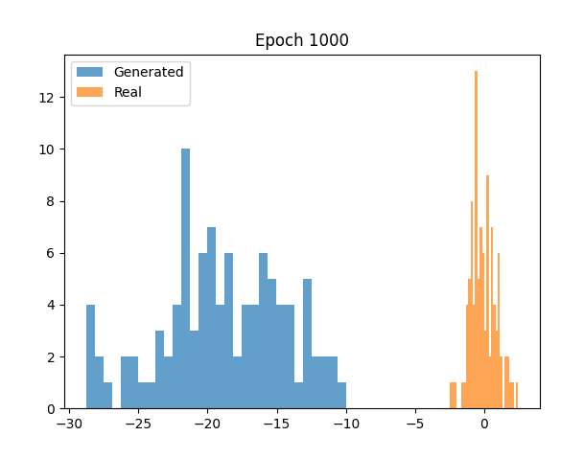

Practical No. 10

Develop an API to deploy your model and perform predictions

Step 1: Train a Model and Save It
Create a file called train.py. This file will train a model, save it using joblib, and visualize feature importance.
# train.py

Train.py
import pandas as pd
import numpy as np
from sklearn.model_selection import train_test_split
from sklearn.ensemble import RandomForestClassifier
from sklearn.metrics import classification_report, accuracy_score
import joblib
import matplotlib.pyplot as plt
import seaborn as sns
from sklearn.datasets import load_iris

# Load the Iris dataset from sklearn
iris = load_iris()
# Convert the data into a DataFrame for easier handling
df = pd.DataFrame(data=iris.data, columns=iris.feature_names)
df['target'] = iris.target
# Quick inspection of the dataset
print(df.head())
print(df.info())
# Data Preprocessing
# Features (X) are all columns except 'target'
X = df.drop(columns=['target'])
y = df['target']

# Split the dataset into training and testing sets (80% train, 20% test)
X_train, X_test, y_train, y_test = train_test_split(X, y, test_size=0.2, random_state=42)
# Initialize the model (RandomForestClassifier in this case)
model = RandomForestClassifier(n_estimators=100, random_state=42)
# Train the model
model.fit(X_train, y_train)
# Make predictions on the test set
y_pred = model.predict(X_test)

# Evaluate the model
print("Accuracy Score: ", accuracy_score(y_test, y_pred))
print("Classification Report:\n", classification_report(y_test, y_pred))

# Save the trained model using joblib
joblib.dump(model, 'trained_model.joblib')

# Optionally: Visualize feature importance (if the model allows it)
features = X.columns
importances = model.feature_importances_
indices = np.argsort(importances)

plt.figure(figsize=(10, 6))
plt.title("Feature Importances")
plt.barh(range(X.shape[1]), importances[indices], align="center")
plt.yticks(range(X.shape[1]), features[indices])
plt.xlabel("Relative Importance")
plt.show()

print("Model saved as 'trained_model.joblib'")

This will create an model names 'trained_model.joblib' files in your directory

output
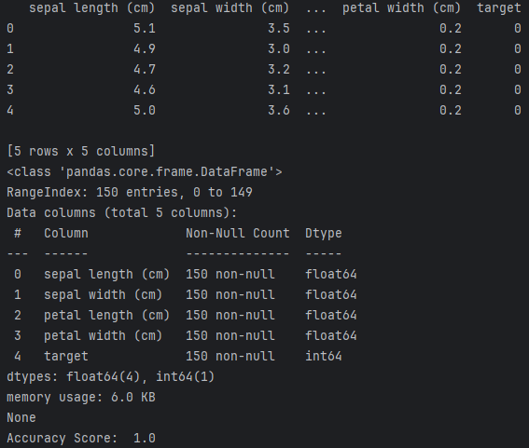
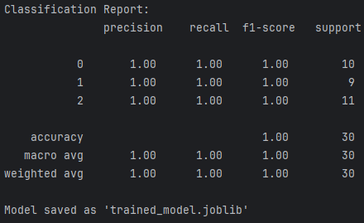
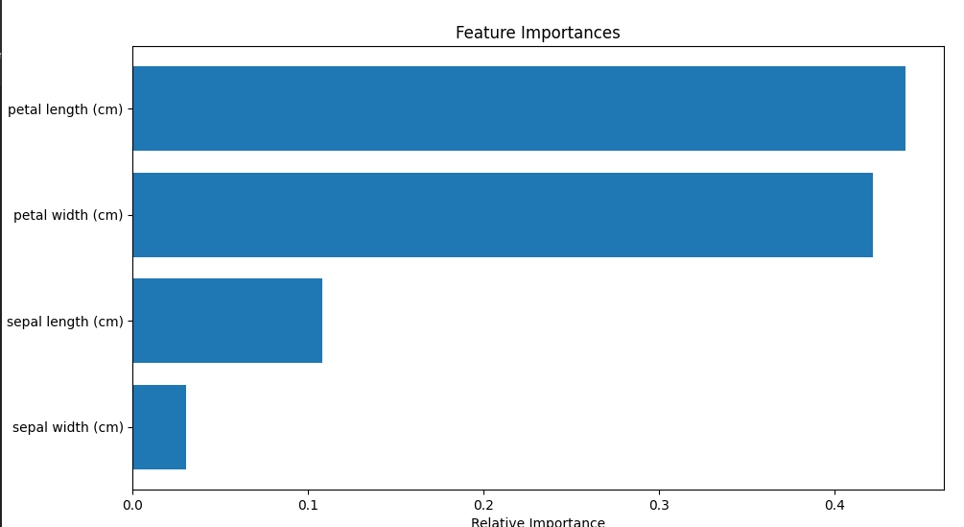

Step 2: Load the Model and Create the API Using FastAPI

Once you have the model saved, create an API using FastAPI. This API will accept inputs via POST requests and return predictions.

Create a file called main.py:
# main.py

Code:

import joblib
from fastapi import FastAPI
from pydantic import BaseModel
from sklearn.datasets import load_iris
import pandas as pd

# Load the trained model from the .joblib file
model = joblib.load('trained_model.joblib')
# Define the input data structure using Pydantic
class FlowerInput(BaseModel):
sepal_length: float
sepal_width: float
petal_length: float
petal_width: float
# Initialize the FastAPI app
app = FastAPI()

# Define a function to make predictions
def predict_species(sepal_length, sepal_width, petal_length, petal_width):
# Prepare the input data as a DataFrame
input_data = pd.DataFrame([[sepal_length, sepal_width, petal_length, petal_width]],
columns=['sepal length (cm)', 'sepal width (cm)', 'petal length (cm)', 'petal width (cm)'])

# Make predictions
prediction = model.predict(input_data)

# Map prediction to actual species names
iris = load_iris()
species = iris.target_names[prediction]
return species[0]

# Define an endpoint for prediction
@app.post("/predict/")
async def predict(flowers: FlowerInput):
# Call the prediction function
predicted_species = predict_species(flowers.sepal_length, flowers.sepal_width, flowers.petal_length, flowers.petal_width)

# Return the result as a JSON response
return {"predicted_species": predicted_species}

Step 3: Run the API

To run the API, use the following command:

uvicorn main:app –reload

This will start a FastAPI app on http://127.0.0.1:8000. You can now make predictions by sending POST requests.

Step 4: Test Your API

Open a powershell and type this command in it
$headers = @{
"accept" = "application/json"
"Content-Type" = "application/json"
}

$data = '{"sepal_length": 9, "sepal_width": 9, "petal_length": 0, "petal_width": 9}'

Invoke-WebRequest -Uri "http://127.0.0.1:8000/predict/" -Method Post -Headers $headers -Body $data

Output will be

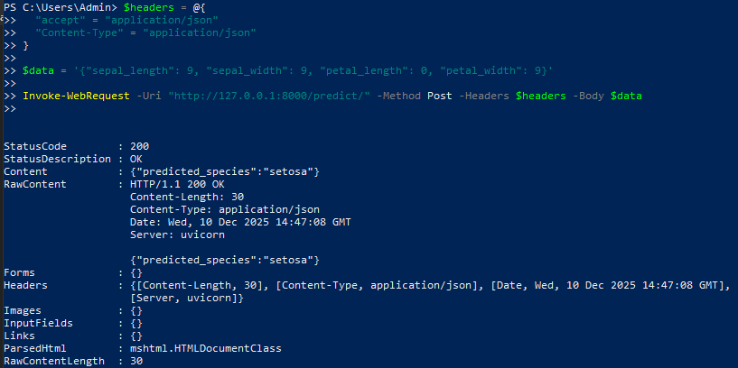

Expected Output:

The API will return a response with the predicted species. The response will look like:
{
"predicted_species": "setosa"
}
This confirms that the API is working, and the model is making predictions based on the input features

